Inheritance Page 227 Exercise 4 Question 8

1. 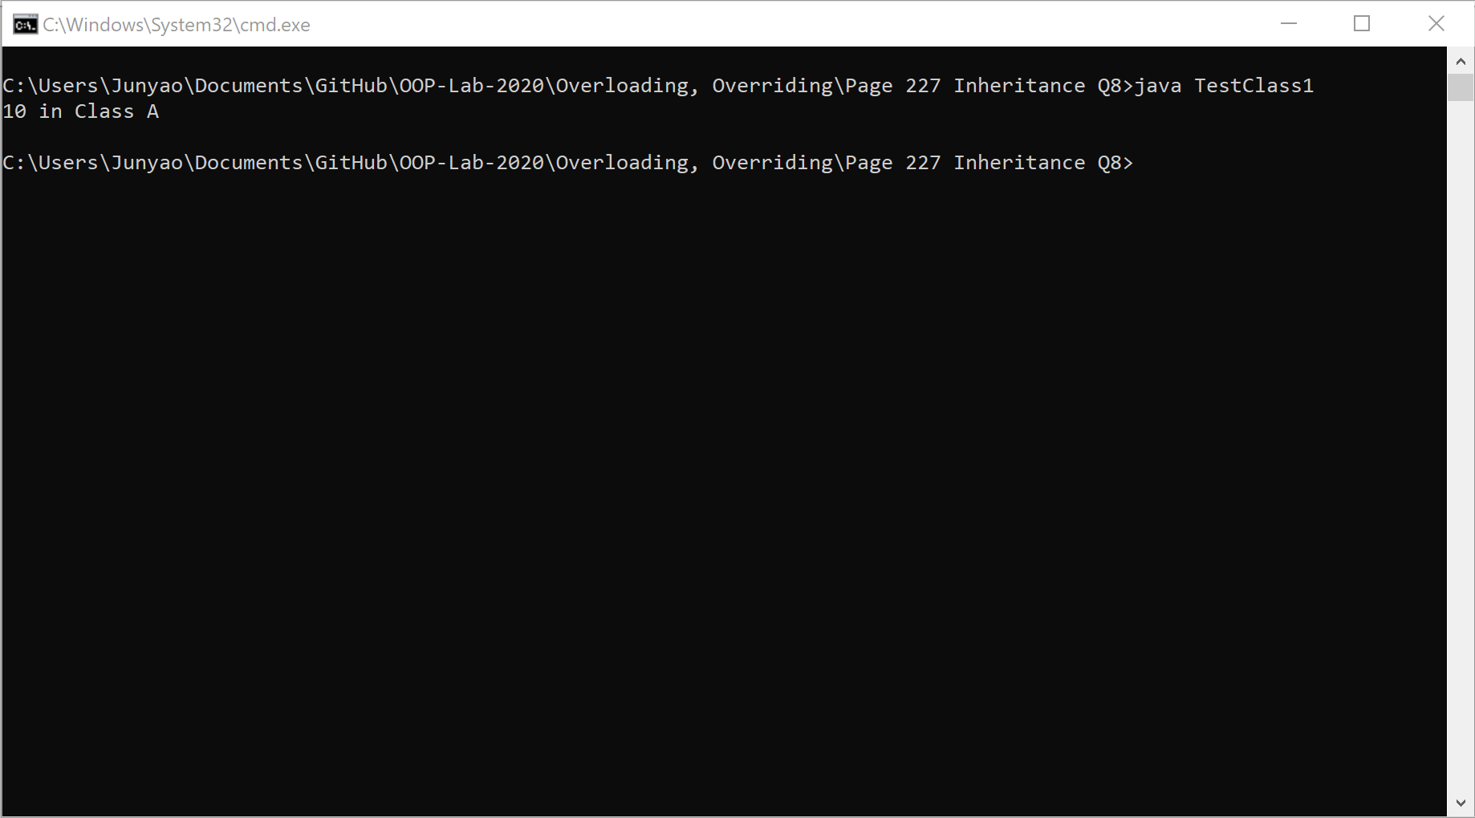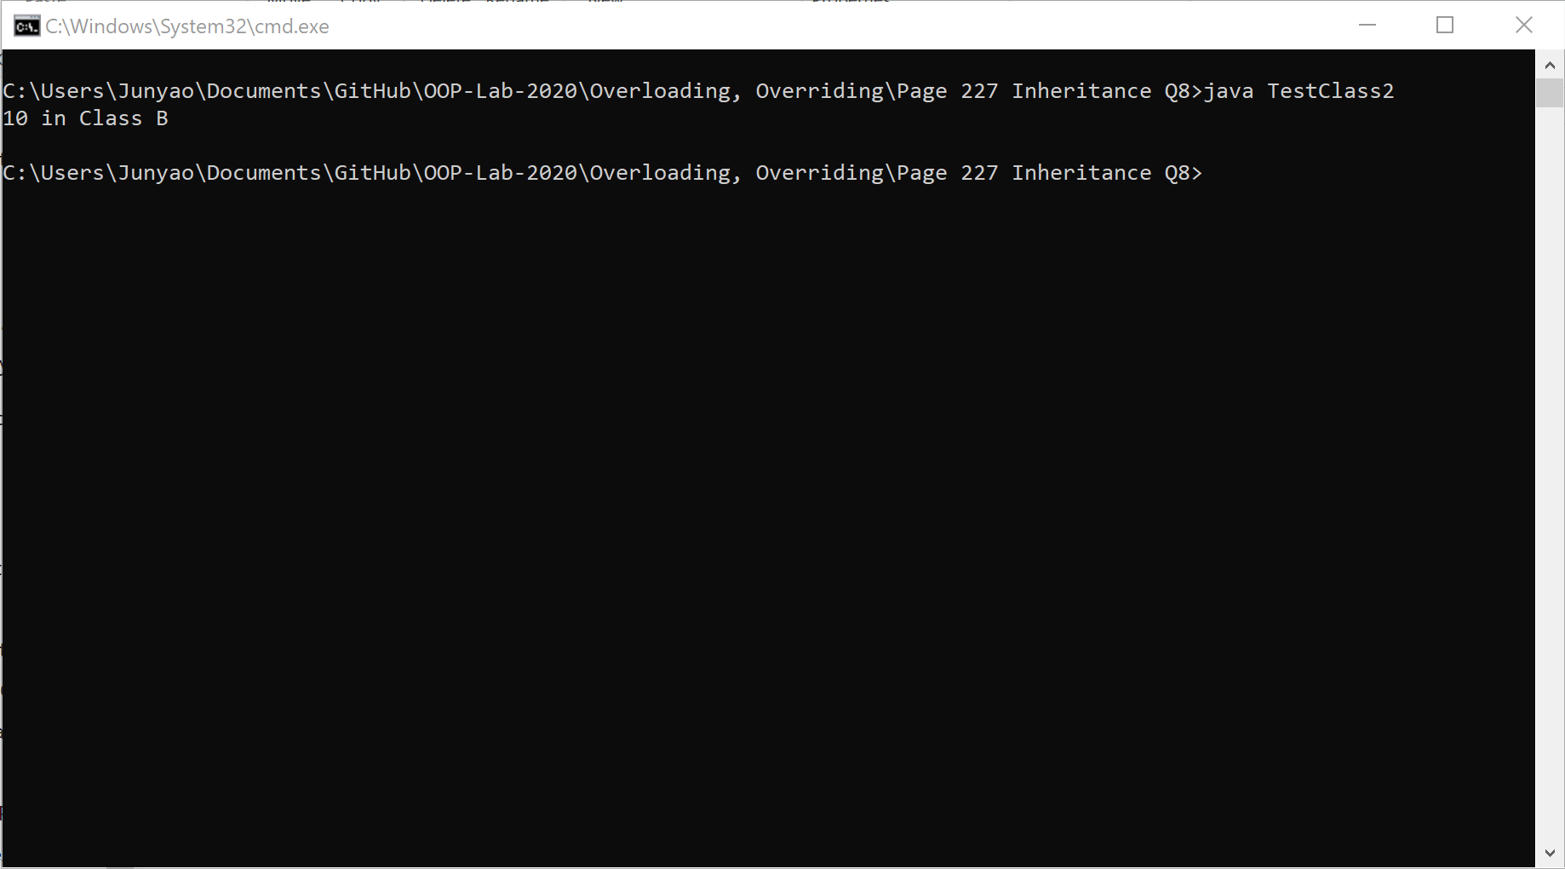

|  |  |
| --- | --- |
| Program | Output |
| TestClass1 | 10 in Class A |
| TestClass2 | 10 in Class B |

|  |  |
| --- | --- |
| Program | Method |
| TestClass1 | Overriding |
| TestClass2 | Overloading |



|  |  |
| --- | --- |
| Overloading | Overriding |
| Must have at least two methods by same name in same class | Must have at least one method by same name in both Parent and child class |
| Must have different number of parameters | Must have same number of parameters |
| If number of parameters are same, then must have different types of parameters | Types of parameters also must be same |
| Overloading know as compile time polymorphism | Overriding knows as run time polymorphism |

Page 228 Question 5 Problem Solving

1. UML Diagram

